**AIRLINE RESERVATION MANAGEMENT SYSTEM**

**Project report submitted in partial fulfillment for the award of the degree of Bachelor of**

**Science in Computer Science**

**Submitted By**

**K. ABIRAMI (2022pgd001)**

**Under the guidance of**

**Head of the department Mr. J. Rajendran, B.E., M.Phil.,**

**DEPARTMENT OF COMPUTER SCIENCE**

**The Madura College**

**Department of Computer Science**

**The Madura College (Autonomous) - Regular**

**(Reaccredited with Grade ‘A’ by NAAC)**

**Madurai- 625011**

**July- 2022**

2



**DECLARATION**

**We hereby declare that the project titled “AIRLINE RESERVATION MANAGEMENT**

**SYSTEM” is a record of original work done by us and which has been carried out as a group project.**

**The project has been submitted to the Department of Computer Science, the Madura College, Madurai,**

**in partial requirement for the requirements of the awarded of the degree of Bachelor of Science in**

**Computer Science.**

**We declare that this report is originally prepared by us and carried out under the guidance of our guide,**

**Head of the department Mr. J. Rajendran, B.E., M.Phil., Department of Computer Science, the Madura**

**College, Madurai and has not been submitted elsewhere for any other degree.**

**PLACE: Madurai**

**K. ABIRAMI (2022pgd001)**

**DATE: ______________**

3

**DEPARTMENT OF COMPUTER SCIENCE**

**THE MADURA COLLEGE (Autonomous)**

**MADURAI- 625011.**

**DEPARTMENT OF COMPUTER SCIENCE**

**BONAFIDE CERTIFICATE**

**This is to certify that the Project work entitled “Airline Reservation Management System” is a Bonafide**

**record work done by K. ABIRAMI (2022pgd001) submitted to the Department of**

**Computer Science, The Madura College, Madurai, in partial fulfillment of the requirements for the award of**

**the degree of Bachelor of Science in Computer Science. The VIVA-VOCE examination was held in the**

**Department of Computer Science, the Madura College, Madurai on _________________**

**Project Guide**

**Head of the Department**

**External Examiner**

**Internal Examiner**

4



**ACKNOWLEDGEMENTS**

**We are happy to present our project titled “Airline Reservation Management System”, submitted for**

**partial fulfillment for satisfying the requirements for award of the degree of Bachelor of Science in Computer**

**Science. We thank God and our parents for presenting us with this opportunity.**

**We thank our college principal Dr.J.SURESH, M.Sc, M.Phil, B.Ed., PBDCA., Ph.D., for providing the**

**support and facilities we needed throughout the course.**

**We express our sincere and heartfelt gratitude to Head of the department Mr. J. Rajendran, B.E.,**

**M.Phil., Department of Computer Science, The Madura College, Madurai for Extending his co-operation and**

**moral support.**

**We are elaborated to place on record our grateful and heartily thanks to our project guide, Head of the**

**department Mr. J. Rajendran, B.E., M.Phil., Department of Computer Science, The Madura College,**

**Madurai for the valuable guidance, inspiration, permission, constant Encouragement, constructed criticism and**

**invaluable help rendered with care and of friendly affection which instilled optimistic idealism that could be**

**converted in to practicalities.**

**We thank all our staff for giving us timeliness help and moral support to complete our project. We**

**would like to express our special gratitude and thanks to industry persons for giving such attention and time**

**for providing necessary information regarding the Project. Finally we would also like to thank my parents and**

**friends who helped me a lot in finishing this project within the limited time.**

**We have taken efforts in this project. However, it would not have been possible without the kind support**

**and help of many individuals and organizations. I would like to extend my sincere thanks to all of them. We**

**made this project not only for marks but to also increase our knowledge.**

5



**THANKS AGAIN TO ALL WHO HELPED U**

**SYNOPSIS**

**Inventory is a physical resource that a firm holds in stock with the intent of selling it or transforming it**

**into a more valuable state. Inventory System is a set of policies and controls that monitors levels of inventory**

**and determines what levels should be maintained, when stock should be replenished, and how large orders**

**should**

**There are many items in a departmental store, which are sold to customers and purchased from suppliers. An**

**order is placed by the customer-required details, which are listed below:**

**be.**

**• Item name**

**• Quantity**

**• Delivery time**

**The order processing executes, look up the stock of each item available or not then order is fulfilled by the**

**management of departmental store. The system periodically checks the store stock of each item if it is found**

**below the reorder level then purchase order is placed to the supplier for that item, if the supplier is not able to**

**supply whole order then rest of quantity is supplied by another supplier.**

**After fulfilled the formalities, a bill is generated by the system and send to the customer. Item details are**

**maintained by the management and this whole process is done manually. Our work area is to automate the**

**above process and to generate more efficient system.**

**The Request for Quotation option should take the user to a page which displays all brands currently available**

**in the showroom (query the MODELS table). Also, an option called “Solar Panel” should be displayed along**

6



**with other brands. When the user clicks on a particular brand, a quotation for that model should be displayed**

**on a separate page, ideally a popup window.**

**TABLE OF CONTENTS**

**PAGE**

**NUMBER**

**S.NO**

**CONTENT**

**1.**

**2.**

**3.**

**Introduction**

**Problem Definition and Description**

**Hardware And Software Requirement**

**Feasibility Study**

**4.1. Economy Feasibility**

**4.2. Technical Feasibility**

**4.3. Operation Feasibility**

**4.**

**5.**

**System Analysis**

**System Design**

**6.1 E-R Diagram**

**6.2 Data Flow Design**

**6.3 Input Design**

**6.4 Report**

**6.**

**7.**

**8.**

**Algorithm**

**Database Structure**

**9.**

**Coding**

**10.**

**Testing and Debugging**

7



**11.**

**12.**

**System Implementation**

**Conclusion**

**13.**

**14.**

**Future Enhancement**

**Bibliography**

8



**1. INTRODUCTION**

**Modules :**

**1.** Registration module:

➢ Ticket information

**2.** passenger module:

➢ Passenger Information

➢ Payment

➢ Ticket Reservation

➢ cancellation

**3.** Administrative module

➢ Flight Information

➢ Enquiry

➢ Passenger information

9



**2. PROBLEM DEFINITION**

The definition of our problem lies in manual system and a fully automated system.

Manual system: The system is very time consuming and lazy. This system is more

prone to errors and sometimes the approach to various problems is unstructured.

Technical system: With the advent of latest technology if we do not update our system then

our business result in losses gradually with time. The technical systems contain the tools of

latest trend i.e. computers printers, fax, Internet etc. The systems with this technology are

very fast, accurate, user-friendly and reliable.

.

TECHNICAL SYSTEM

Need of Airlines system

A few factors that directs us to develop a new system are given below -:

**1)** Faster System

**2)** Accuracy

**3)** Reliability

**4)** Informative

**5)** Reservations and cancellations from anywhere to anyplace

10

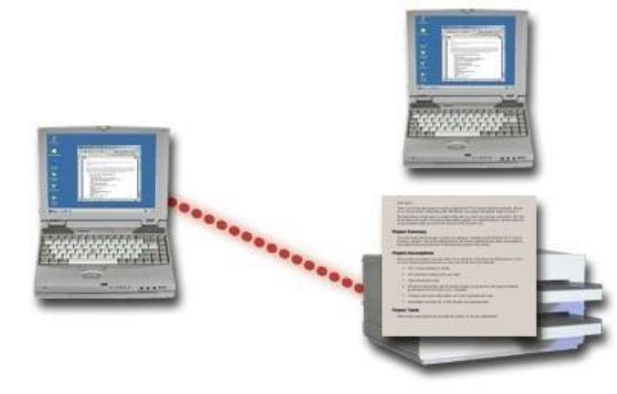

AIRLINES SYSTEM

RESERVATION

CANCELLATION

UPDATION

UPDATION

11

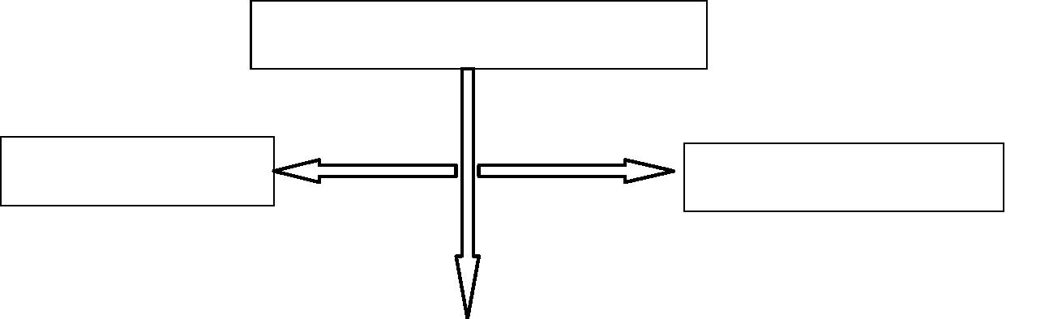

3. SYSTEM ENVIRONMENT

**3.1.** HARDWARE REQUIREMENT

The above Hardware specifications were used in both Server and Client machines when

developing.

Processor

:

:

Pentium 4

2.5 GHz

Processor Speed

Ram

:

:

:

:

:

:

:

512 MB

80GB

Hard Disk Drive

Floppy Disk Drive

CD-ROM Drive

Monitor

Sony

Sony

17” inches

TVS Gold

Logitech

Keyboard

Mouse

**3.2.** SOFTWARE REQUIREMENT

Operating System

Technology Used

Database

:

:

:

Windows 8

Vb.Net

MS-Access

12



**4. SYSTEM ANALYSIS**

This was the most important phase of my projects life cycle. It had connected my

maximum time.

**4.1.Existing System**

•

•

In the existing system, much of the data is entered manually and it can be very time

consuming

When record are accessed frequently, managing such records becomes difficult.

Therefore organizing data becomes difficult

**4.2.proposed System**

•

•

•

•

The proposed system is designed to meet all the disadvantages of the existing one.

The proposed system is better and more efficient.

The primary aim of the new system is to speed up the transactions.

User friendly.

5.SYSTEM DESIGN

In this phase initially I had designed E-R diagram of the processes, in order to identify various

entities and relationship set, entity set, attributers, link attributes The Diagram of this process as

under.

After this step we had tried design the data base for the new system and normalized it

the tables motivated in data dictionaries enclosed as annex II is an outcome of this step

The symbol of entities are shown bellow

13



Entity sets

Oval

**5.1.DATA FLOW DIAGRAM**

In order to design a better solution. I had designed the DFD for system including all

technical processing details is given bellow

14

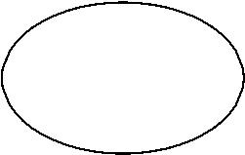

LEVEL0 DATA FLOW DIAGRAM

REQUEST FORINFORMATIONFLIGHT/FARE/DISCOUNT

INFORMATION

PASSENGER

1.0

GENERAL

ENQUIRY

BOOKING

ENQUIRY

NEW PNRINFORMATION

2.0

PASSENGER

ENQUIRY

RESERVATION REQUEST

3.0

BOOKING

COUNTER

TICKET CONFIRMATION &STATUS

CANCELLATION REQUEST

ACKNOWLEGMENT

4.0

CANCELLATION

15

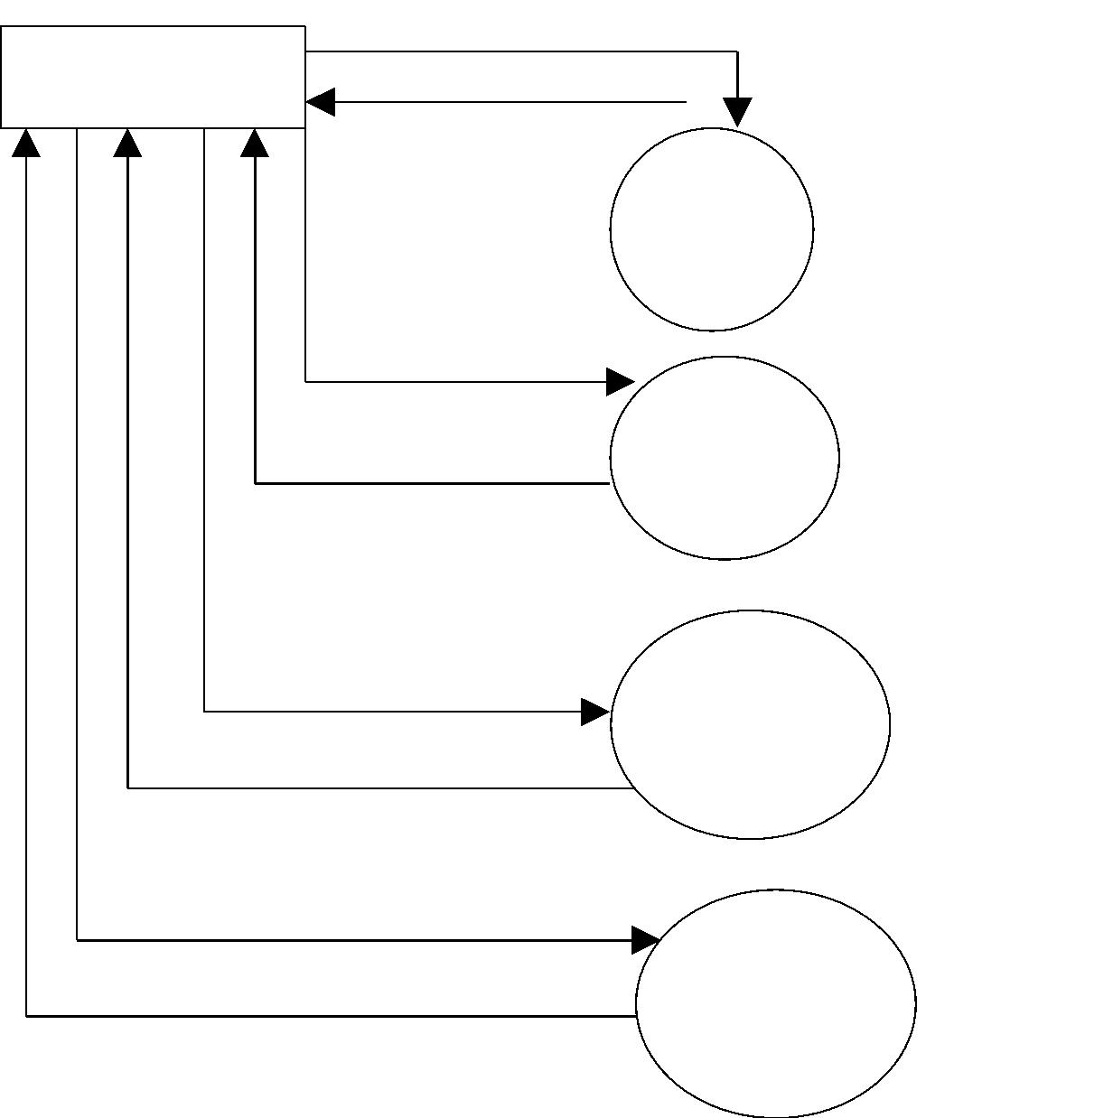

LEVEL 1 DATA FLOW DIAGRAM OF PASSENGER ENQUIRY

**SECTION**

PASSENGER

ENTRY OF NEW RECORD OR EXISTING

PASSENGER ENQUIRY

NEW PNR OR REQUIRED INFORMATION

PASSENGER

ENQUIRY

R

E

Q

U

N

I

Q

U

E

P

N

R

I

N

F

R

E

Q

U

O

E

U

E

S

T

S

T

2.2

PASSENGER

ENQUIRY

NEW

PASSENGER

R

UNIQUE

PNR

R

INFORMATION

PASSENGER

PASSENGER

16

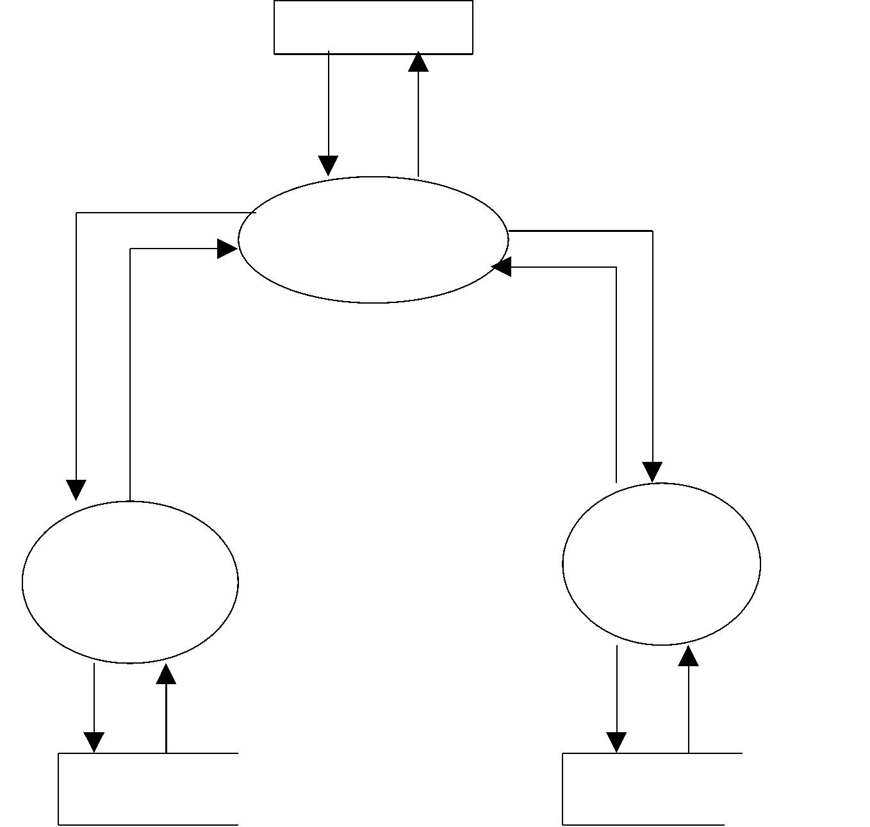

LEVEL 2 DFD OFCANCELLATION

PASSENGER

REQUEST FORCANCELLATION

ACKNOWLEDGEMENT

UPDATE

CANCELLATION

CANCELLATION

SECTION

ACKNOLEDGEMENT

VALIDITY CHEQUE

4.3

VALIDITY

CHEQUE

4.1

CANCEL

TICKET

4.2

RESHEDULE

A

C

K

N

O

L

CHEQUE

VALID

REQUEST

FOR

STATUS

CANCEL

NEW

A

C

K

E

DATE

D

G

E

PASSENGER

PASSENGER

PASSENGER

17

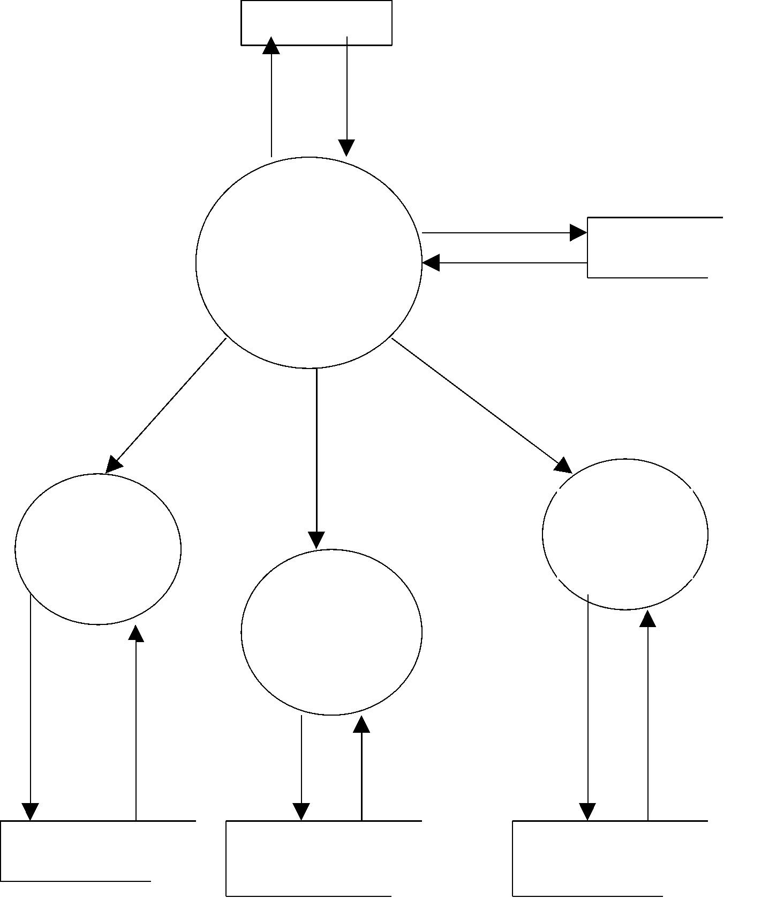

**INPUT DESIGN**

**The input design consists of developing specification and procedures for data**

**preparation and to input data into the computer for processing. Simply we can say input**

**design is the processor of converting the user generated inputs into computer based format.**

**The important features of input screen are:**

• **Input screen is user friendly.**

• **The input validation is being done at program level to discard unauthorized users.**

**Few of the activity to be carried out during the input design phase are:**

• **Identification of data entry forms along with the data elements.**

• **Identification of data elements and tables for database creation.**

• **Computation of procedures explaining the process of deriving the output from the**

**given input.**

**Therefore, designing forms and other input screens comes under the category of the input**

**design.**

**Data structure is defined through a process called normalization. Data are grouped in**

**the simplest possible way so that later changes can be made with a minimum impact on the**

**data structure. The normalization of these entries in to attributes linked by common data**

**element to form relationships improves the effectiveness of database management system.**

18

**OUTPUT DESIGN**

**The main objective of any system is the generation of reports. Reports provide the source**

**of information required. Reports can be used for quick references and it gives the collection of**

**details. Reports also provide a permanent hard copy of the results after transactions. Careful**

**considerations have been given in designing the reports as it helps in decision making.**

**The designing of input play a very significant role in getting the correct output. It covers all**

**phases of input from creation of initial data to system for processing. The output design is the link**

**that ties the information system into the world of its users. Output design for the proposed system**

**falls on the following areas.**

•

**Controlling the amount of input**

•

**Avoiding delay**

**Controlling the amount of input:**

**In proposed system, unwanted fields are avoided and also redundancy respective references are**

**avoided. Thus the amount of the input is reduced considerable. So, the data entry operation will be**

**reduced considerably.**

**Avoiding delay:**

**Data processing is delayed owing of data preparation as if is done manually. Avoiding the time delay**

**is the major objective of the proposed system and it is achieved through this software with in time.**

19

**9. CONCLUSION**

Though the system still containing lot of scope of improvement in it. But its overall look and feel

gives rough picture of on existing automation system.

I have taken MS-Access at backhand but it has a limitation of 1 GB size .It over data size

approaches this 1gb some other database the SQL server ,oracle, can be used with OBBC to

break this barrier.

**10.FUTURE ENHANCEMENT**

The current system has vital improvement areas which done when makes it a completed System

Makes it a complete system. The key domains which when enhanced from the newly

implemented System make it a complete system.

.

• The system was developed in visual basic.

• To make the user easier to interact we have created the project in

Visual Basic and Oracle 9i. We can also implement the system in LAN environment To make the

System available for more than one user.

• To bring this application into Internet for using different branches in The same Company and getting

orders from Internet.

• To bring this information into mobile for getting order through Mobile devices.

• To bring Business to customer concept in near future.

20



**11. BIBLIOGRAPHY**

**BOOKS**

1. Mastering in VB.NET, Even Gelo Petroutsos

2. Programming in Visual Basic 6.0, Htozer

3. Murchis Visual Basic 6.0, Edloop, Anne Prince, Joel Murach

4. Introduction to Ms Access, Nancy Greeberg, Priya Nathan

REFERRED WEBSITES

VB.NET

**1.** www.vb.net/(S (pdfrohu0ajmwt445fanvj2r3))/learn/data-access/

**2.** www.w3schools.com/vb/default.asp

**3.** www.411vb.net /home/sites

**4.** www.cristiandarie.ro/vb-tutorial/

**5.** Www. Vb.net -tutorials.com/basics/first-website/

MS ACCESS

**1.** www.functionx.com/msaccess/

**2.** www.technet.microsoft.com/en-us/library/msaccess69620.aspx

**3.** [www.msdn.microsoft.com/en-us/library/ms169620(msacce](http://www.softwaretrainingtutorials.com/ms-%20access%20-2005.php)ss).aspx

**4.** www.softwaretrainingtutorials.com/ms- access -2005.php

***************THEEND******************

21

